User guide for Problem 2: Customer Retention Model

**Prerequisites**

1. Python 3
2. Jupyter Notebook
3. Visual Studio Code
4. GitHub Account

**Section 1: Data Cleaning**

1. Open Jupyter notebook
2. Open Data Cleaning for Prob2.ipynb
3. Uncomment and run the first cell to install pandas, numpy, sklearn.

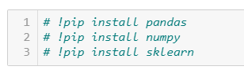

1. Run the 2nd cell to import pandas and numpy packages

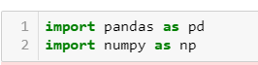

1. Import the dataset to be cleaned. Change “train.csv” to the name of the file. This can be both the training file and testing file.

Note that for training file, labels need to be the at the right most column

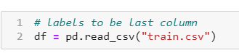

1. Continue running the cells to check how many records there are in the dataset, number of rows that contain NA values and drop these NA values.
2. Check for features that are unique to each customer using df.nunique()
   1. If there are features that are unique to each customer for eg. CustomerID, remove them by running the next 2 cell.

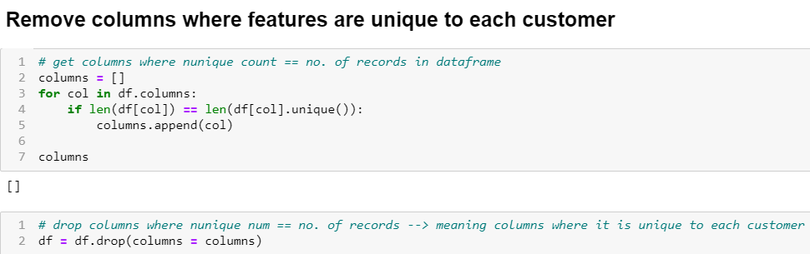

1. Check that columns that have values unique to each customer has been removed by running the next cell, df.head()
2. Next, we will be performing data standardization. Data standardization should only be applied to column where values are **continuous (**decimal for eg. 1.23) NOT discrete (whole number for eg. 0,1,2,3)

Note: Change columns_to_scale to column headers where its values are continuous

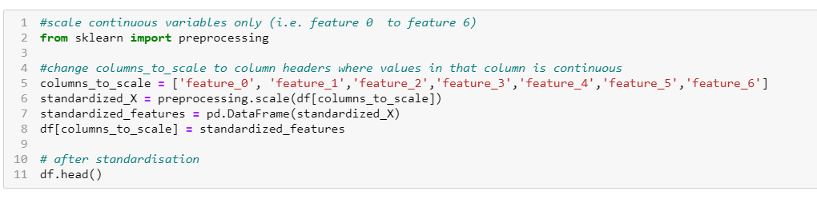

1. Next, we will perform label encoding to convert textual data to numerical data as machine learning models cannot work with text.
   1. Add all the columns name into a list called feature

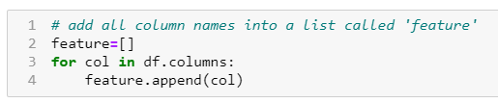

* 1. Check value type of each column

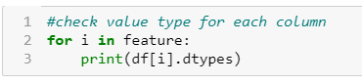

* 1. If value type of column is ‘object’, it will be encoded into numbers

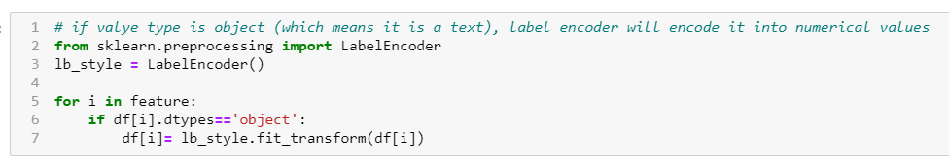

* 1. Check that textual values have been changed into numbers by running df.head()

1. Export the cleaned dataset. You can rename the file to any name you prefer by changing ‘train_cleaned’. Note that the extension ‘.csv’ is required.



1. Perform data cleaning for both the train and test file and export them so that they can be uploaded into the flask model on Heroku (next section).

**Section 2: Customer Retention Prediction Model**

1. Go to <https://github.com/DataNinjas-code/prudential>

* Download the file

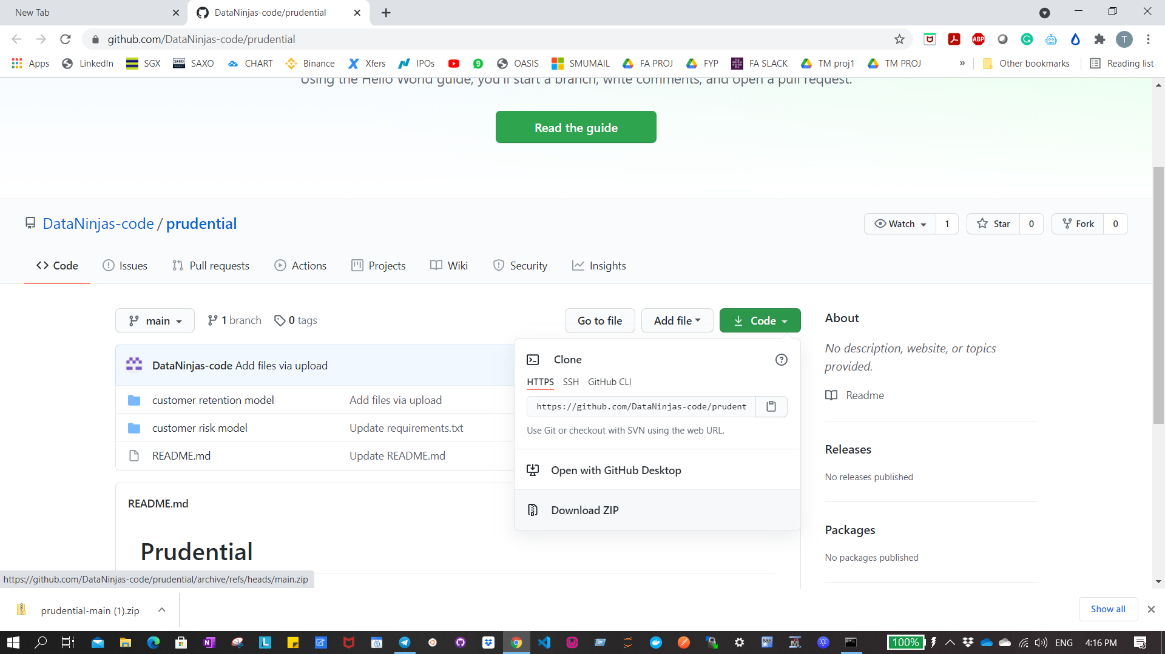

* Extract the contents in the zip file
* Click into the folder and into ‘customer retention model’
* Click on the file path (make sure your file path is similar to the screenshot)

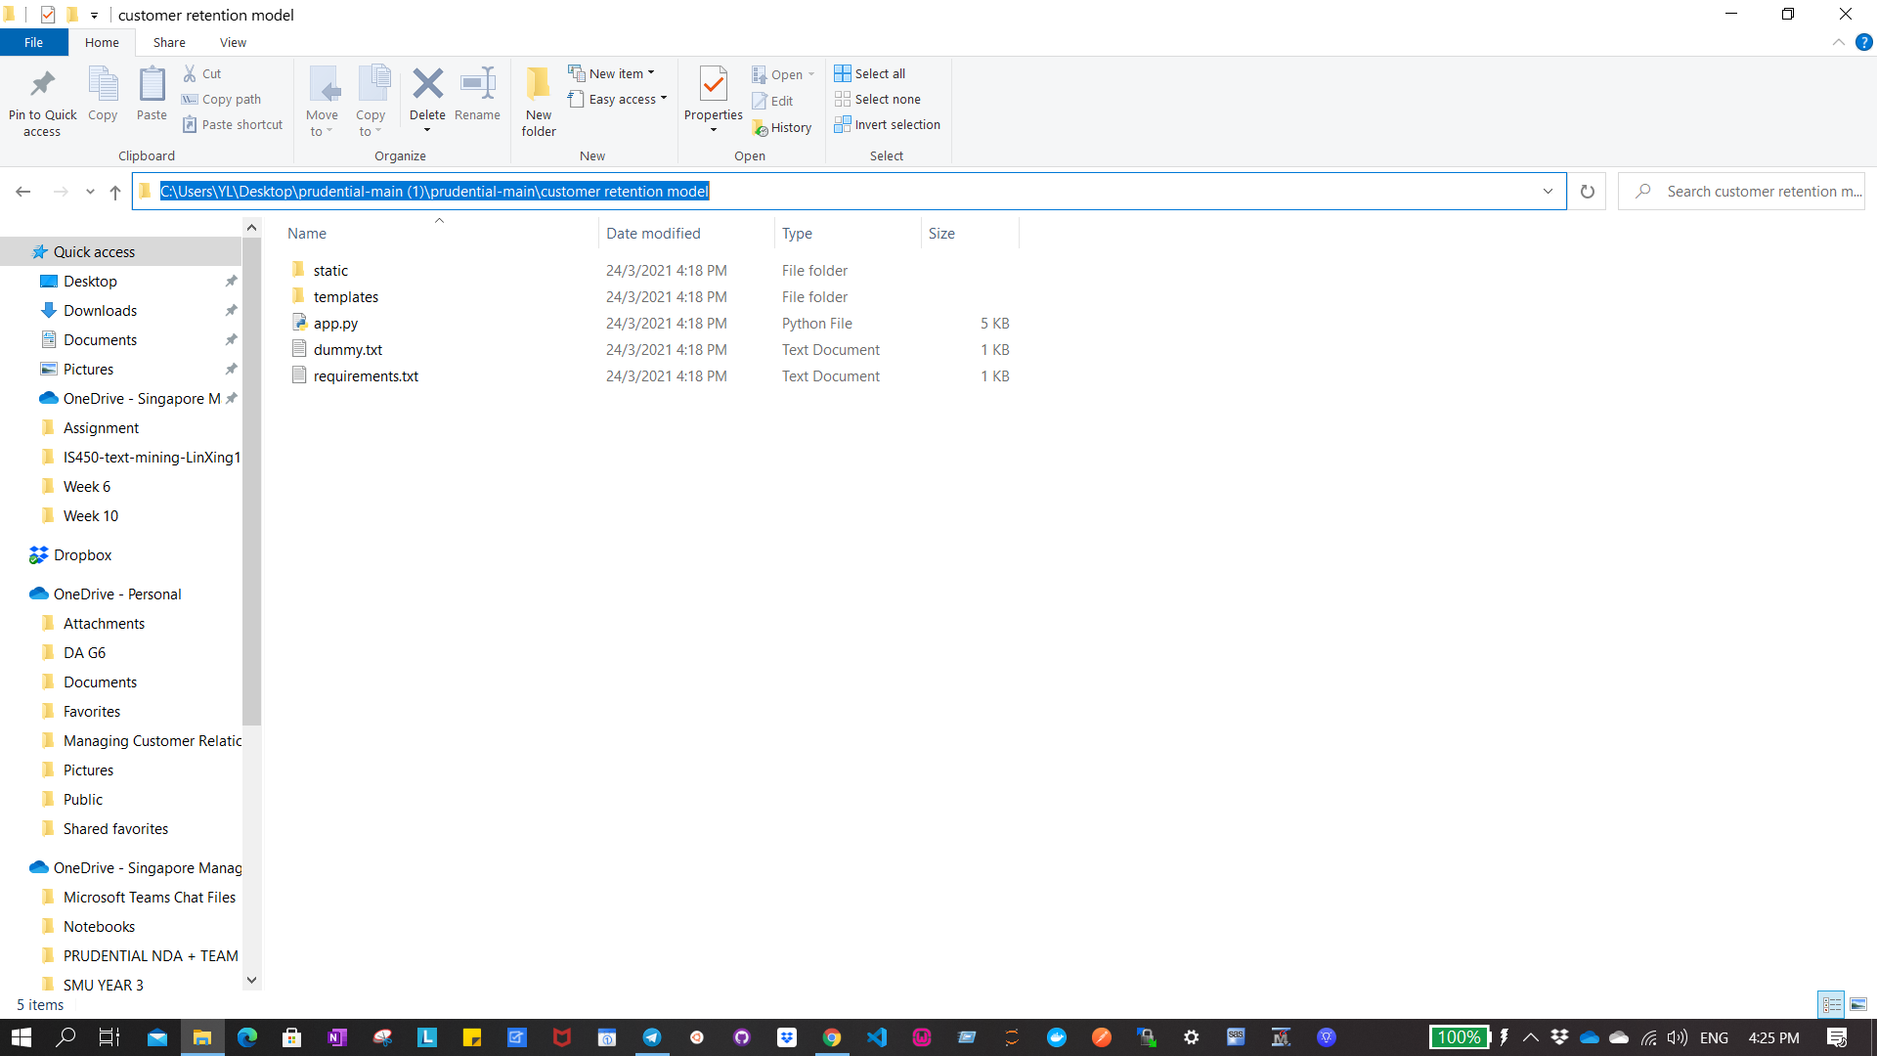

* Type ‘cmd’ and press enter

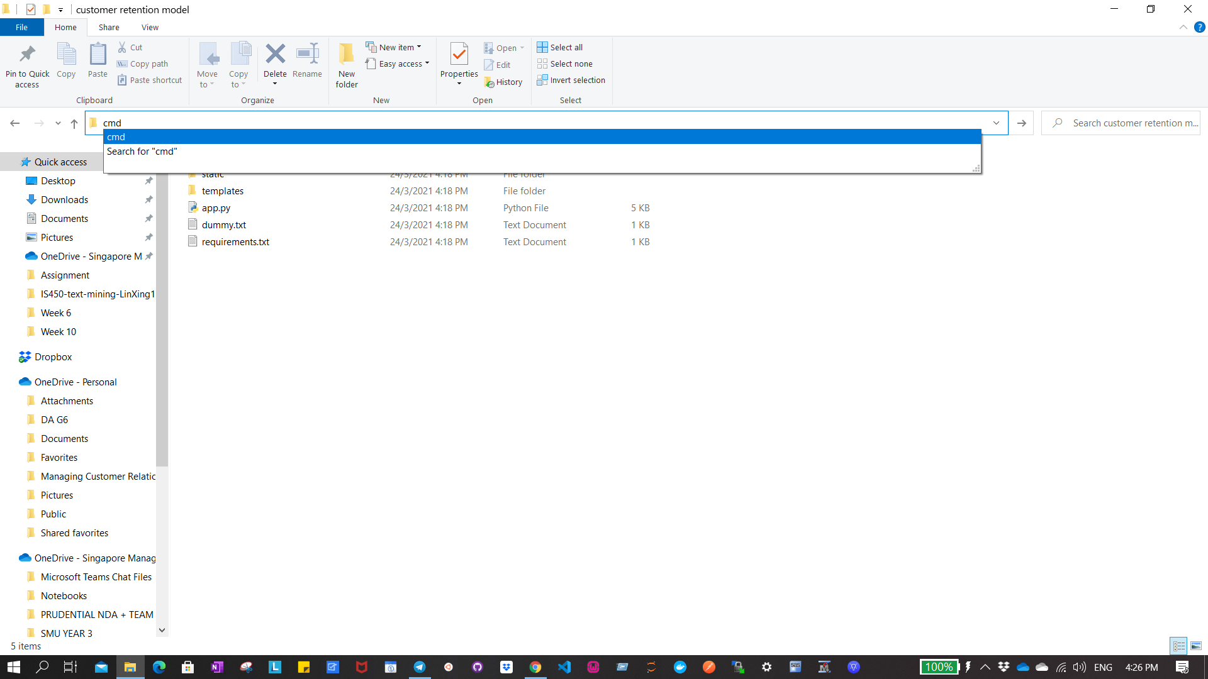

* You will see your command prompt being opened up.

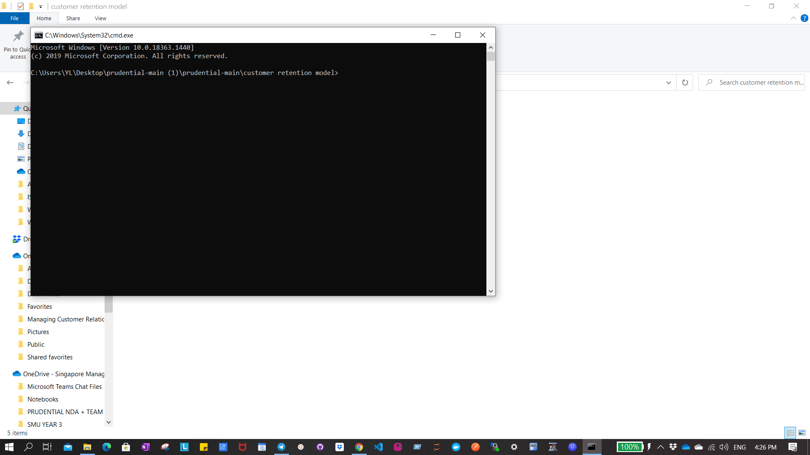

1. Pip install all the required packages using requirements.txt by typing:

pip install -r requirements.txt

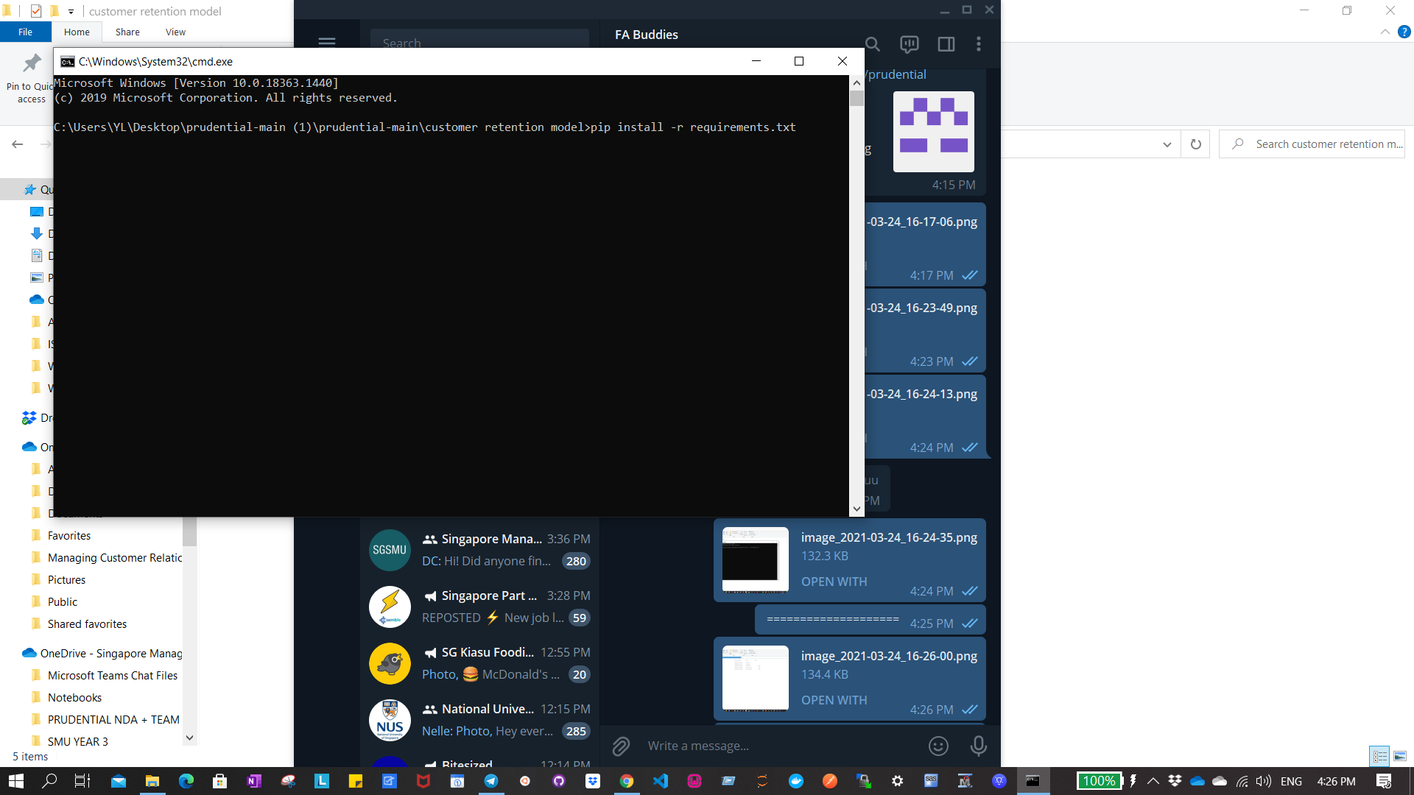

1. Run the Flask App by typing:

python app.py

You should see this which means the flask app is live and running.

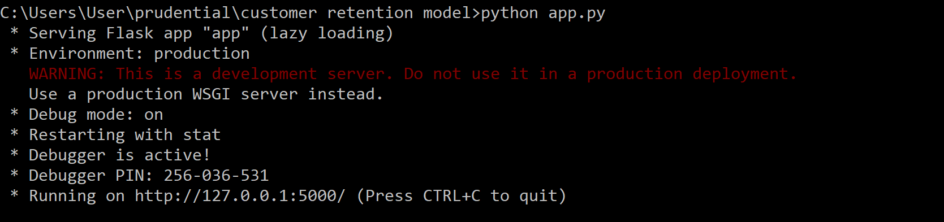

1. Go to the link: <http://127.0.0.1:5000/> and you should see this page below:

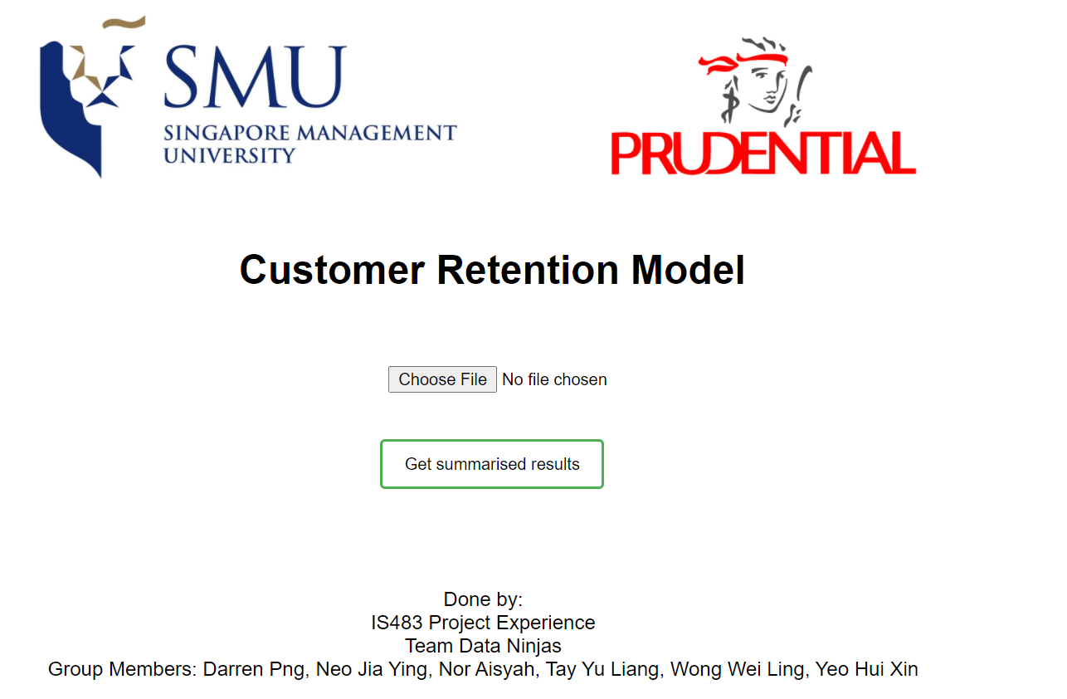

1. Upload cleaned training file by clicking on the “Choose File” button.

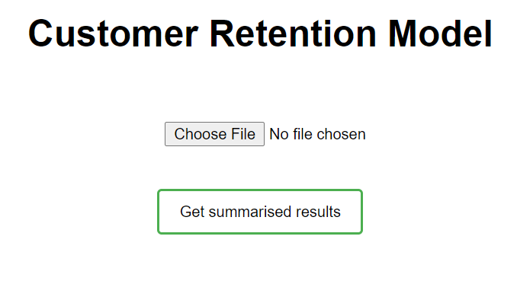

1. Click on ‘Get summarised results’ button to get the metrics for these models: Random Forest, Extra Trees and XGBoost.



1. After clicking on ‘Get summarized results’, you will need to wait for a while, depending on how much data you have uploaded, before seeing this page. At this page, you can see the accuracy, precision, recall and f-score of the 3 models.

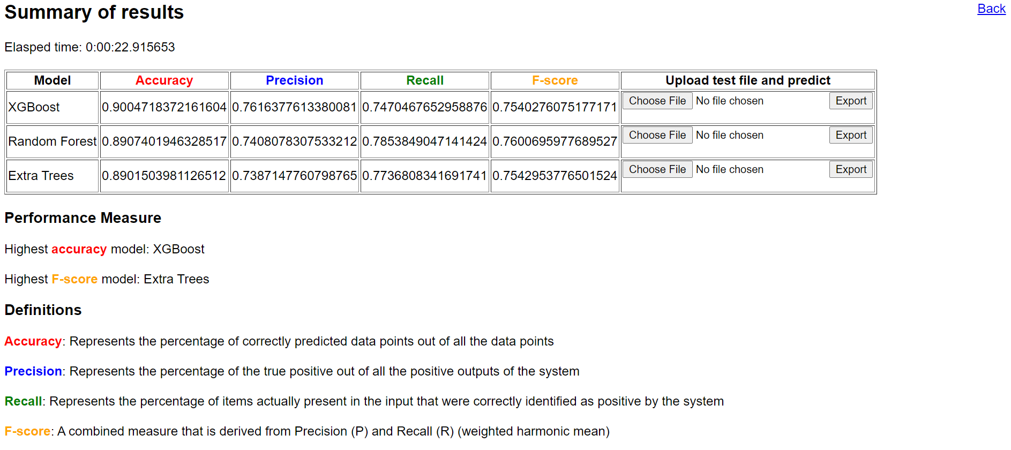

1. To choose the best model to predict the labels on your test file:

For the model chosen

* + 1. Upload test file
    2. Click “export”



1. Once you click on ‘export’, a file will be downloaded. This file contains the labels predicted by the respective model on the test file you uploaded.

**Section 3: Clustering Model**

1. Open Jupyter notebook
2. Open Clustering for Customer who churned.ipynb OR Clustering for Customer who retained.ipynb
3. Uncomment and run the first cell to install pandas, numpy, seaborn and matplotlib.

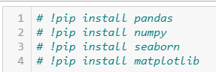

1. Run the 2nd cell to import packages

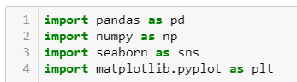

1. Import the test file that you exported in section 2 (the file with labels predicted). Change the file name to import accordingly.

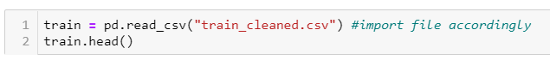

1. Run all the cells until you reach the elbow plot.

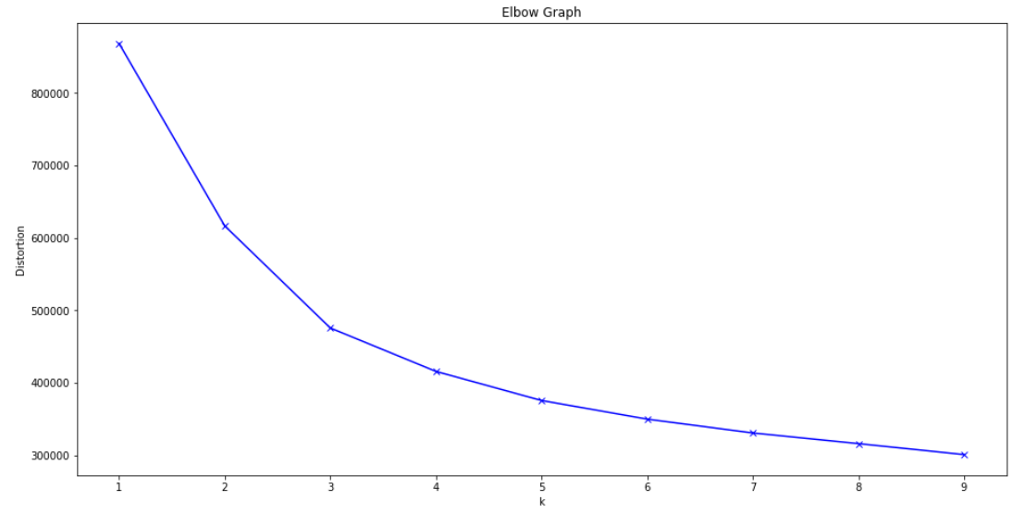

Elbow point is when the decrease in distortions is not as significant as k increases. In this case, the elbow point occurs when k=5.

1. For Kmeans clustering, change n_clusters to the elbow point’s k.



1. Continue running the cells until you reach this heatmap.

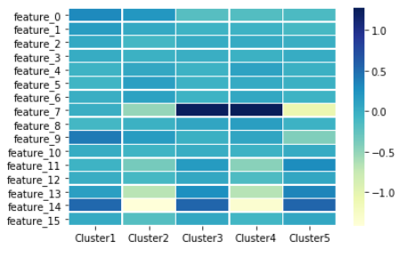

This heatmap tells you the highly ranked variables in each cluster. The highly ranked variables are shaded in very light yellow or very dark blue.